Thomas Jackson

11/7/17

P6

Computer Science FINAL PROJECT

Hello, everyone. My name is Thomas Jackson. I have decided to make an RPG recommender website (which I’m SURE has been done by someone before). I chose it because I originally wanted to do a project on BattleBots, which is a show in which people make robots that are designed to fight other robots made by other people, but it somehow got rejected, and I ended up having to do everything all over again… Anyways, my project is for those who do not know what RPGs they should play, as well as my classmates. I am using a code called CSS, which deals with the making of websites. I’ve worked on it in WordPress, which allows emails of any kind to join in. There are many, many, many, MANY problems that came with this project, including: a) learning CSS, which I overcame by going to code.org, b) choosing where to make a site—I solved this by going to WordPress—and c) getting people to improve the site—which I helped make easier by making the site public. I could PROBABLY use coding in order to make videogames OR robots. I have gone too far to turn back now, and besides, the project’s due ON DECEMBER, the SAME month in which we CELEBRATE CHRISTMAS!!!

# Screenshots

The about page. This was easier than the rest to me.

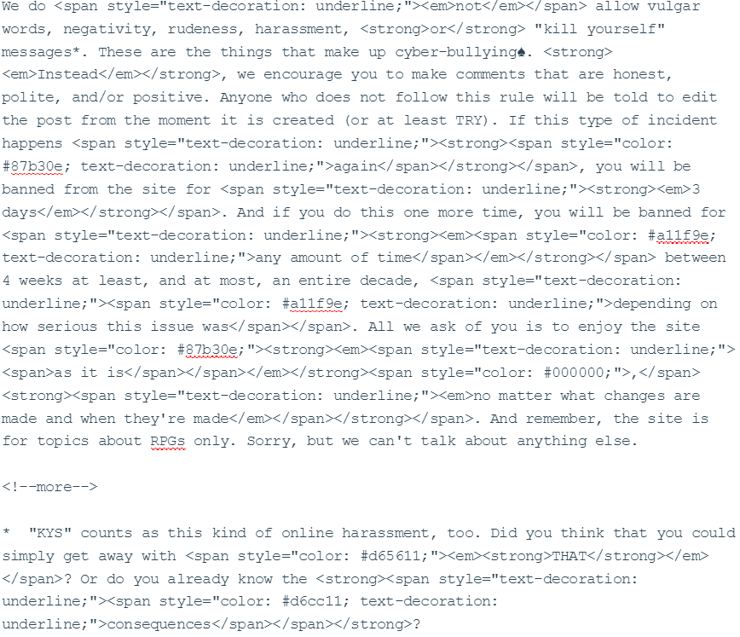

The CSS code for MOST of the rules for the site’s comment sections.